Name:

Spark Inquiry Test

Answer the following short answer questions, please show your work

1. Find the length of the hypotenuse.

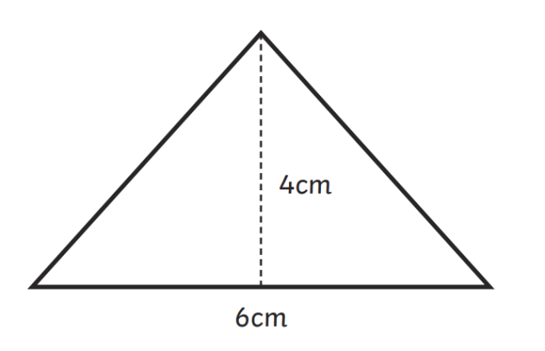

1. Solve. State your solution as an improper fraction.
$\frac{32}{5}×\frac{20}{16}$

2. There are 5 different colours of paper in a package. If there are 3 sheets of red paper, 5 sheets of yellow, 7 sheets of green, 6 sheets of blue, and 4 sheets of orange paper. What are the chances of drawing either a green sheet of paper or a blue sheet of paper? Express your answer as a percentage.
3. 3 sheets of green paper, 1 sheet of blue, and 1 sheet of yellow paper were drawn out. Now what is the chance of drawing a green or blue sheet of paper? Express your answer as a percentage.

4. Solve for x:

5. If Amelia has a square apartment with an area of 36m, what is the side length of the apartment?

6. Find